Property history of Downgate Farmhouse, Furnace Lane, Warbleton, Heathfield TN21 9AZ, 2nd Feb 2013

Previously listed for sale on 2nd Feb 2013
Guide price £1,350,000 - 5 bedroom property

Previously marketed by
Knight Frank - Tunbridge Wells (view all property for sale)
Churchill House 85 Mount Pleasant Road, Tunbridge Wells, TN1 1PX

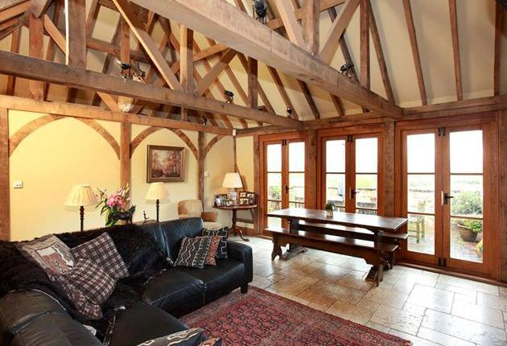

Property features
- 5 bedrooms
- 3 reception rooms
- 3 bathrooms
- Outbuildings
- Period
- Detached
- Garden
- Land
- Listed
- Rural
- Village
- Private Parking
- 6.00 acres

Property description
Occupying a stunning position with lovely views over its own paddock & surrounding countryside. Garage & gym, double car port with studio/ office above. About 6 acres. EPC rating D.
The property is situated within in Area of Outstanding Natural Beauty in an accessible, semi-rural location, about 1 mile from the idyllic & picturesque village of Rushlake Green. This extremely attractive Grade II Listed period farmhouse has recently undergone a thoughtful & sympathetic restoration programme which includes a stunning kitchen / breakfast room & dining room / playroom with doors opening to a terrace with magnificent views. The house is full of character and most of the rooms have lovely views over the gardens, paddocks & farmland beyond.
The accommodation also includes an impressive double aspect drawing room with inglenook fireplace; sitting / dining room; boot room & laundry room; master bedroom with en-suite shower room; 4 further bedrooms & family bathroom.
Outside, there is a large building which provides garaging & gym / store behind, and a detached English Heritage style double car port with a useful studio / office & en-suite shower room above.